

network layer

Introduction to Networking and Security



October 27, 2019

Jamie lu

W0441213

Table of Contents

Introduction: 3

Question 4 4

Activity 6.1.3.3 4

Activity 6.1.4.6 5

Activity 6.2.2.8 5

Question 6 6

Activity 6.3.1.8 6

Part 1: 6

Part 2: 6

SCREENSHOTS: 7

SCREENSHOT 6 OF ACTIVITY 6.3.1.8 12

SCREENSHOT 6 OF ACTIVITY 6.3.1.8 – CABLE CONNECTIONS 13

Question 7 13

Activity 6.4.1.3 13

Part 1: 13

Part 2: 14

Part 3: 15

SCREENSHOT 1 OF ACTIVITY 6.4.1.3 16

SCREENSHOT 2 OF ACTIVITY 6.4.1.3 17

Question 8 18

Multiple Locations 1 – Configuring Routers with a GUI 18

Task 1: 18

SCREENSHOT 1 OF MULTIPLE LOCATIONS 1 18

SCREENSHOT 2 OF MULTIPLE LOCATIONS 1 19

Question 9 20

Multiple Locations 2 – The Command Line Interface 20

SCREENSHOT 1 OF MULTIPLE LOCATIONS 2 20

SCREENSHOT 2 OF MULTIPLE LOCATIONS 2 21

Question 11 22

Activity 6.5.1.3 22

SCREENSHOT 1 OF ACTIVITY 6.5.1.3 22

SCREENSHOT 2 OF ACTIVITY 6.5.1.3 23

SCREENSHOT 3 OF ACTIVITY 6.5.1.3 24

SCREENSHOT 4 OF ACTIVITY 6.5.1.3 – IP CONFIGURATION OF USER-01 25

SCREENSHOT 5 OF ACTIVITY 6.5.1.3 – IP CONFIGURATION OF USER-02 26

SCREENSHOT 6 OF ACTIVITY 6.5.1.3 – IP CONFIGURATION OF USER-03 27

SCREENSHOT 7 OF ACTIVITY 6.5.1.3 – IP CONFIGURATION OF USER-04 28

References 29

Appendix 30

Appendix A – Cisco Commands Tool Kit 30

# Introduction:

This assignment contains activities that used learnings from Cisco’s CCNA R&S: Introduction to Networking: Chapters 6[1], as well as, useful information from the Cisco IOS Configuration Fundamentals Command Reference[2]. This assignment also contains the information learned and skills acquired with regards to the topics that were covered, namely, the IP Protocol, IPv4, IPv6, routers and configuring them, enterprise level networking, communications closets and server rooms, and rack mounted equipment. This assignment also contains the continuation of the case study that was mentioned in the previous assignments. It tackles on what is needed to configure routers with a GUI as well as applying learnings about the command line interface. This assignment also shows an updated version of the Cisco commands tool kit.

# Question 4

## Activity 6.1.3.3

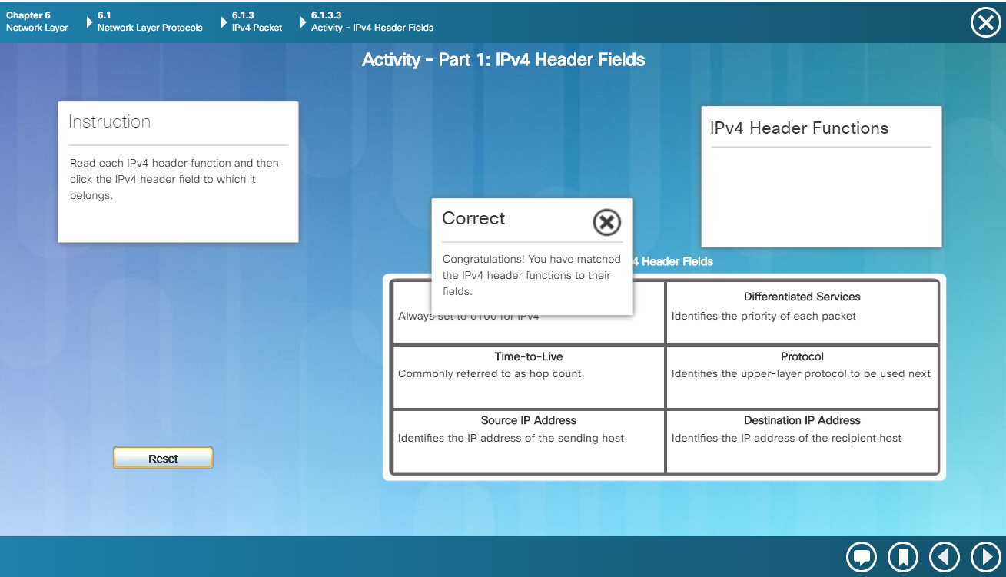

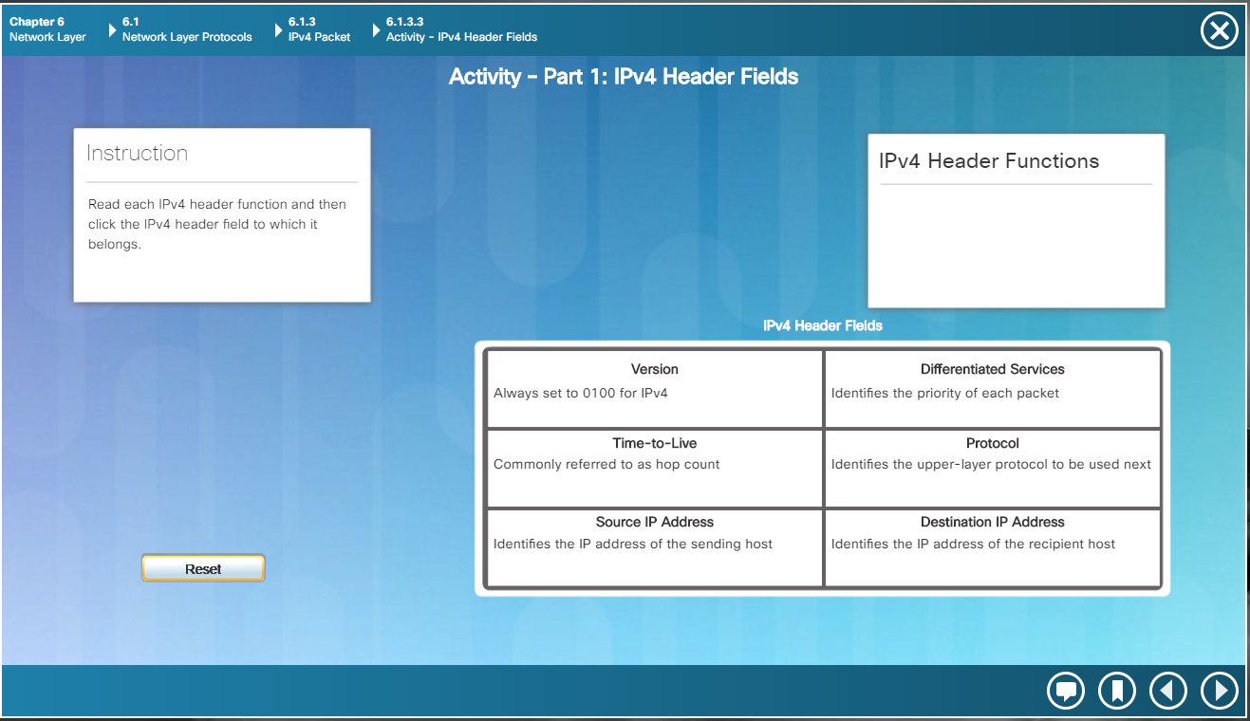

## Activity 6.1.4.6

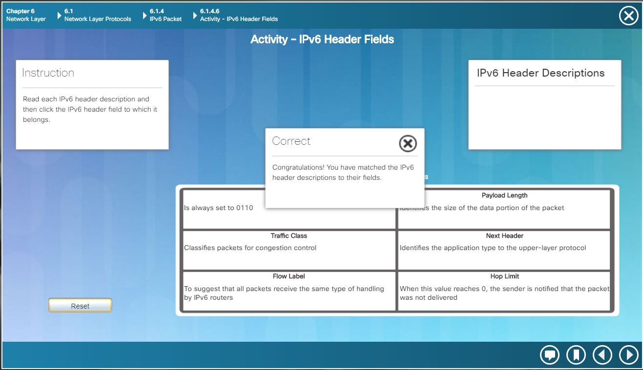

## Activity 6.2.2.8

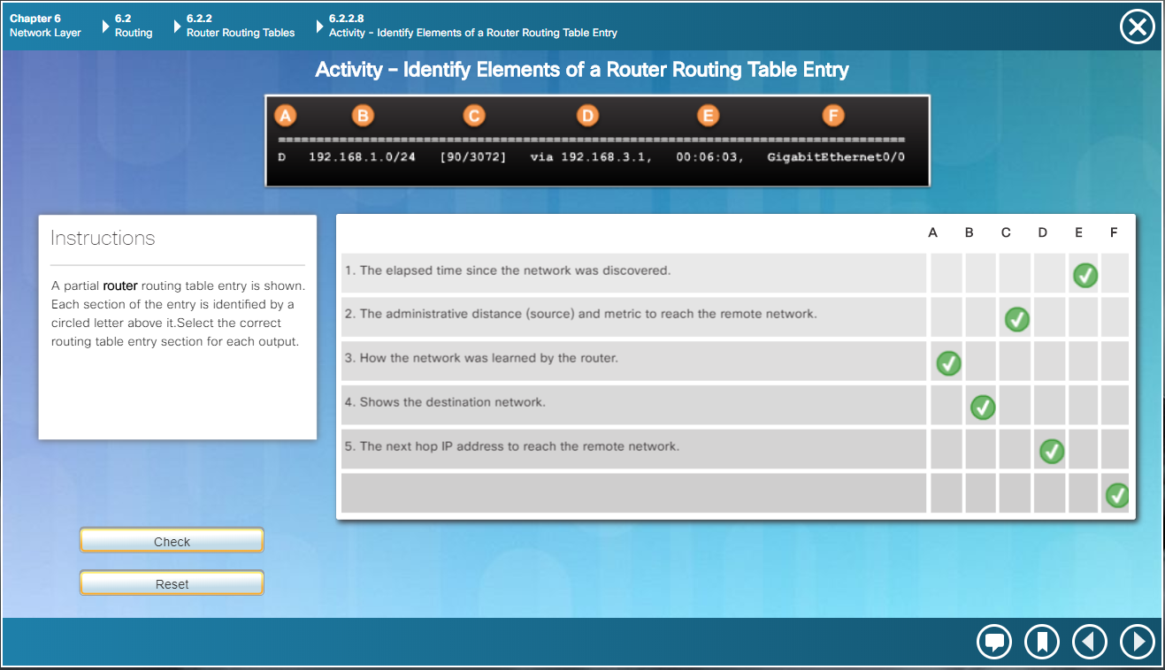

# Question 6

## Activity 6.3.1.8

### Part 1:

#### Step 1:

C. Which management ports are available?

- The AUX and Console ports

#### Step 2:

A. Which LAN and WAN interfaces are available on the East router and how many are there?

- There are 2 WANs and 2 Gigabit Ethernet interfaces

B. How many physical interfaces are listed?

- There are 4 physical interfaces.

C. East> **show interface gigabitethernet 0/0**

What is the default bandwidth of this interface?

- The default bandwidth is 1000000 Kbit

East> **show interface serial 0/0/0**

What is the default bandwidth of this interface?

* The default bandwidth is 1544 Kbit

#### Step 3:

A. How many expansion slots are available to add additional modules to the **East** router?

- There is only 1 expansion slot

B. How many expansion slots are available?

- Switch 1 and Switch 2 both have 5 expansion slots each

### Part 2:

#### Step 1:

A.1. Which module can you use to connect the three PCs to the **East** router?

- You can use the HWIC-4ESW module which provides four switching ports

A.2.  How many hosts can you connect to the router using this module?

- You can connect 4

B. Which module can you insert to provide a Gigabit optical connection to **Switch3**?

- You can insert the PT-SWITCH-NM-1FGE to provide a Gigabit optical connection to switch3

#### Step 2:

D. Into which slot was it inserted?

- It was inserted to the GigabitEthernet 5/1 slot

### SCREENSHOTS:

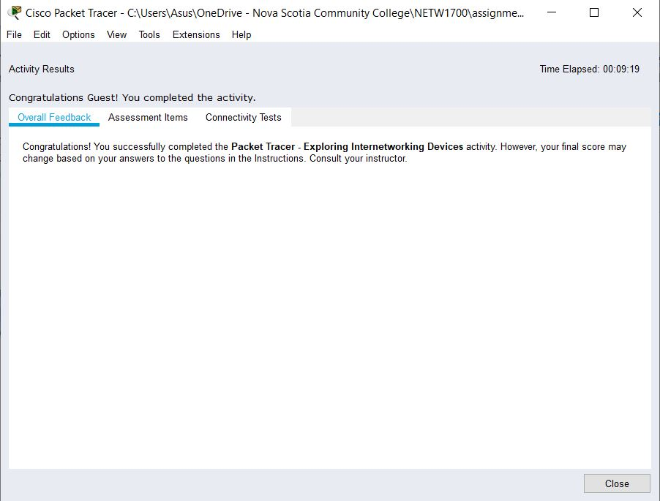SCREENSHOT 1 OF ACTIVITY 6.3.1.8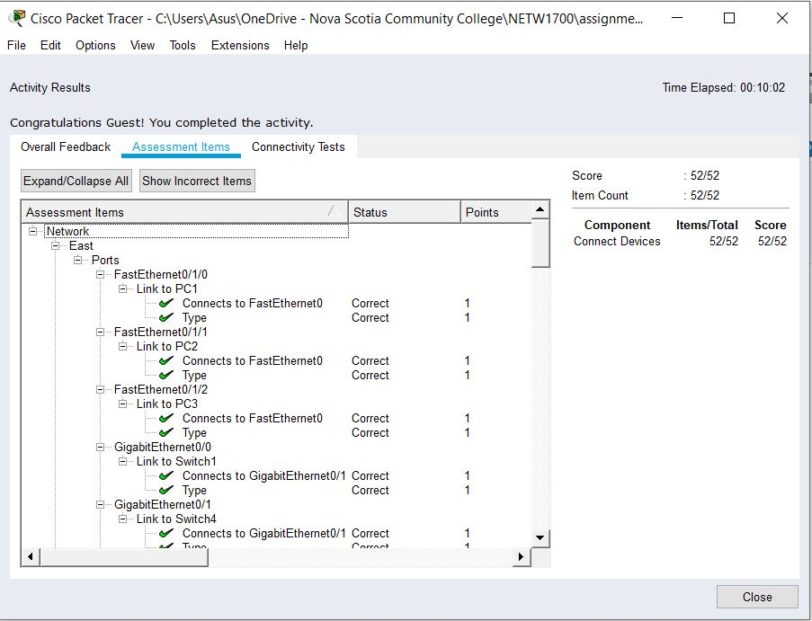SCREENSHOT 2 OF ACTIVITY 6.3.1.8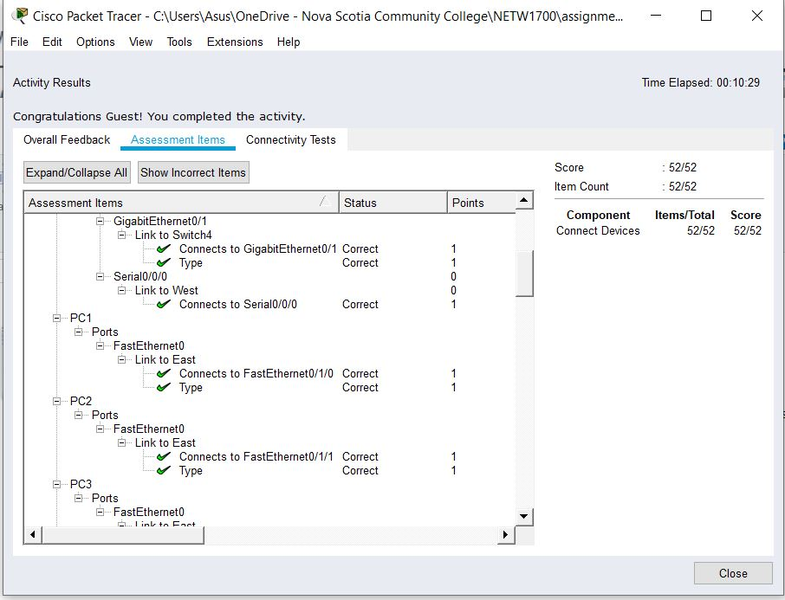SCREENSHOT 3 OF ACTIVITY 6.3.1.8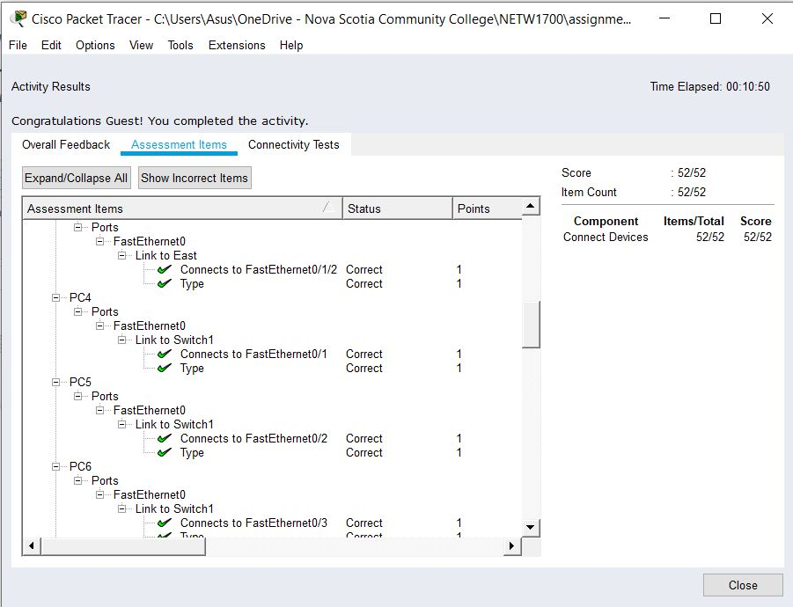SCREENSHOT 4 OF ACTIVITY 6.3.1.8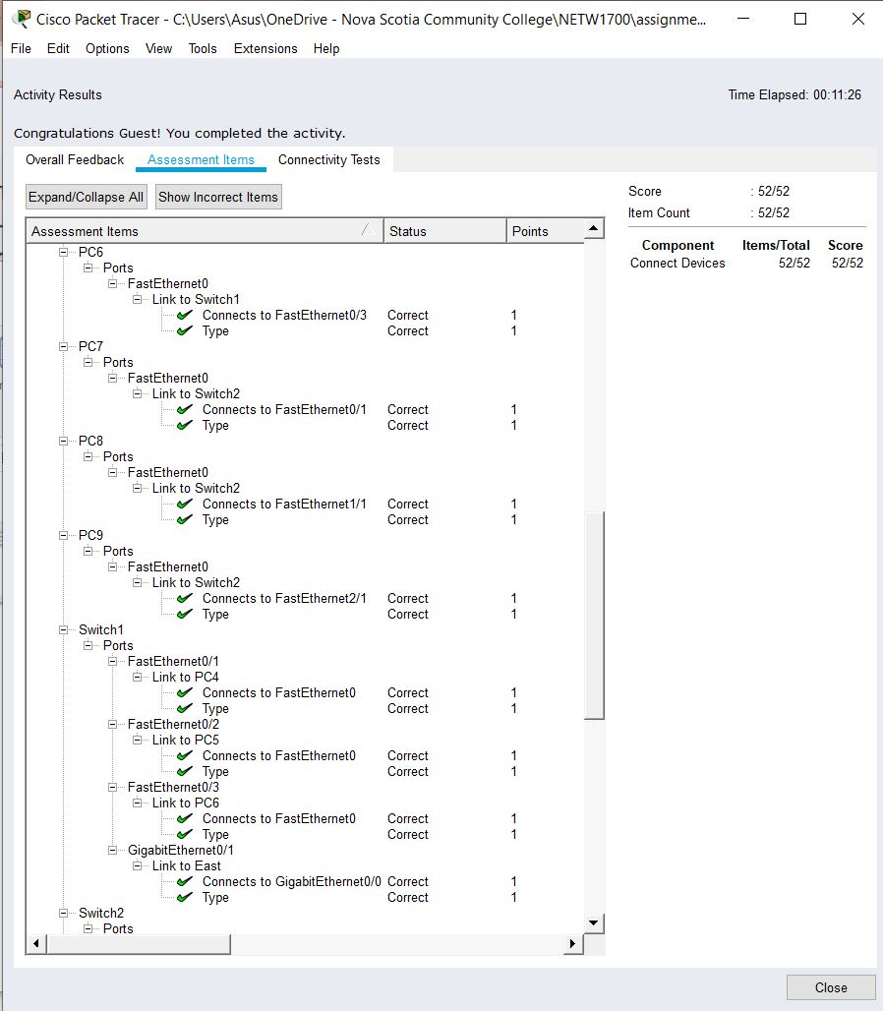SCREENSHOT 5 OF ACTIVITY 6.3.1.8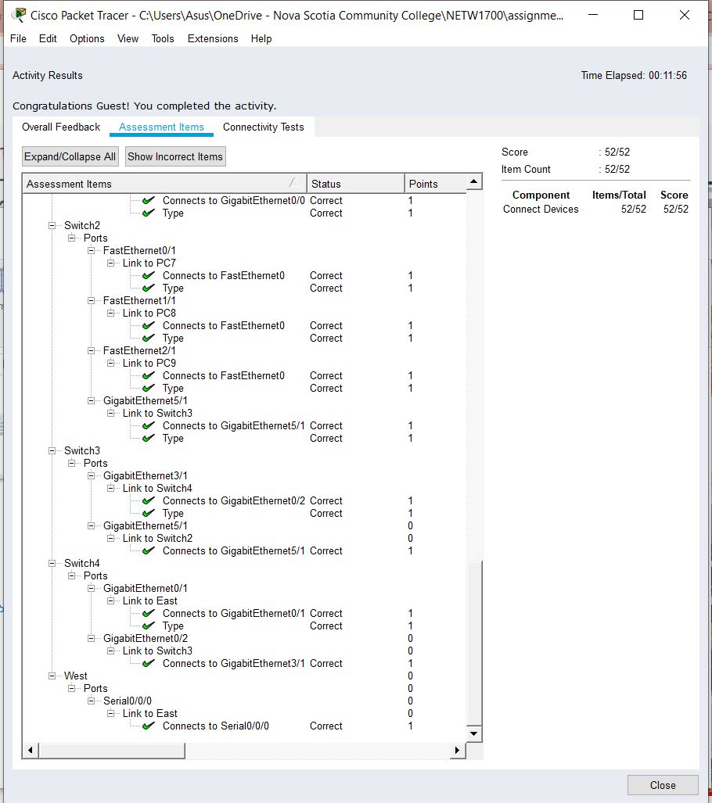

SCREENSHOT 6 OF ACTIVITY 6.3.1.8

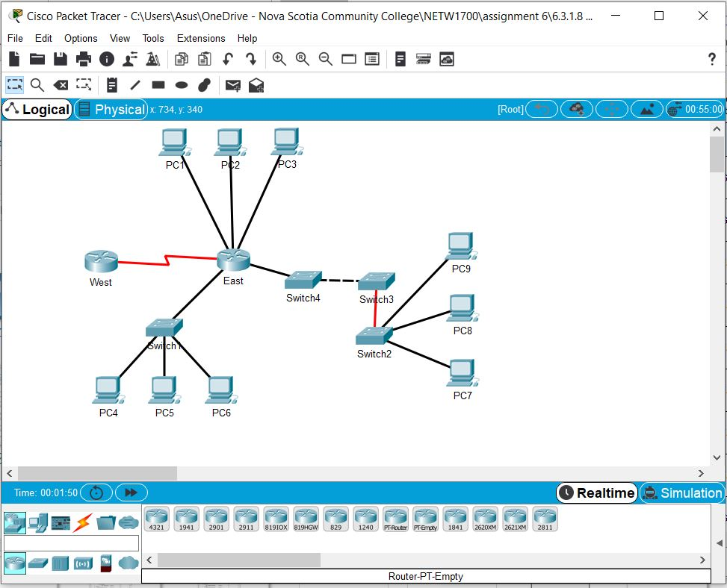

SCREENSHOT 6 OF ACTIVITY 6.3.1.8 – CABLE CONNECTIONS

# Question 7

## Activity 6.4.1.3

### Part 1:

#### Step 2:

C. What is the router’s hostname?

- The router’s hostname is “router”

How many Fast Ethernet interfaces does the router have?

- There are 4 Fast Ethernet interfaces

How many Gigabit Ethernet interfaces does the Router have?

- There are 2 Gigabit Ethernet interfaces

How many Serial interfaces does the router have?

- There are 2 Serial interfaces

What is the range of values shown for the vty lines?

- The range of values shown for the vty lines is 0-4

Why does the router respond with the startup-config is not present message?

- It shows this message because the configuration is currently located in the RAM (which is why it shows up in when show running-config command is entered) and it is not saved to the NVRAM.

### Part 2:

#### Step 2:

A. What command do you use?

- show running-config

C. Why should every router have a message-of-the-day (MOTD) banner?

- Every router should have the MOTD banner because it gives information to users about the accessibility of the router and warns unauthorized users that access is prohibited but at the same time can be used to send messages to the network technicians.

What console line command did you forget to configure?

- the line console was not configured. You need to first go to privileged exec mode, then global configuration mode, then enter in line console 0, then password letmein (or whatever password you would like to set), then log in, then exit.

D. Why would the **enable secret** password allow access to the privileged EXEC mode and **the enable password** no longer be valid?

- enable secret password overrides the enable password which is why the enable password will no longer be valid.

If you configure any more passwords on the router, are they displayed in the configuration file as plain text or in encrypted form? Explain.

- The passwords added on the router would be in encrypted form. This is because of the service password-encryption command. This command encrypts all the current passwords as well as any password that is added.

### Part 3:

#### Step 1:

A. What command did you enter to save the configuration to NVRAM?  
 - copy running-config startup-config

What is the shortest, unambiguous version of this command?

- copy r st

Which command displays the contents of the NVRAM?

- show startup-config

#### Step 2:

A. How many files are currently stored in flash?

- There are 3 files currently stored in flash

Which of these files would you guess is the IOS image?

- I would guess that the IOS image is the c1900-universalk9-mz.SPA.151-4.4.M4.bin

Why do you think this file is the IOS image?

- I think that this is the IOS message because of the file extension (“.bin”)

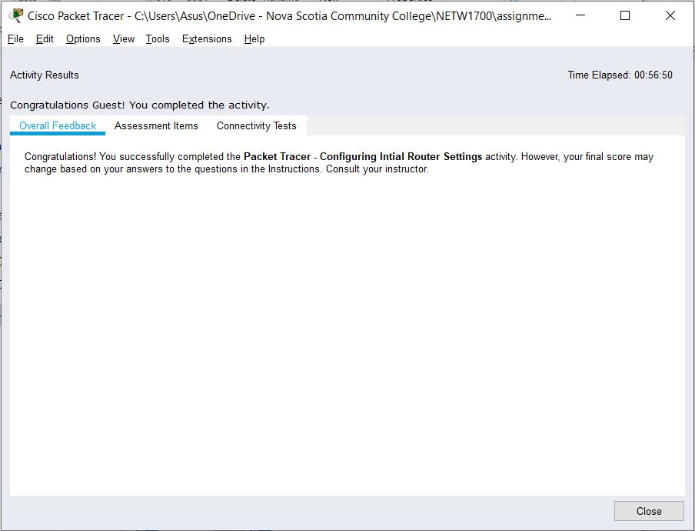

SCREENSHOT 1 OF ACTIVITY 6.4.1.3

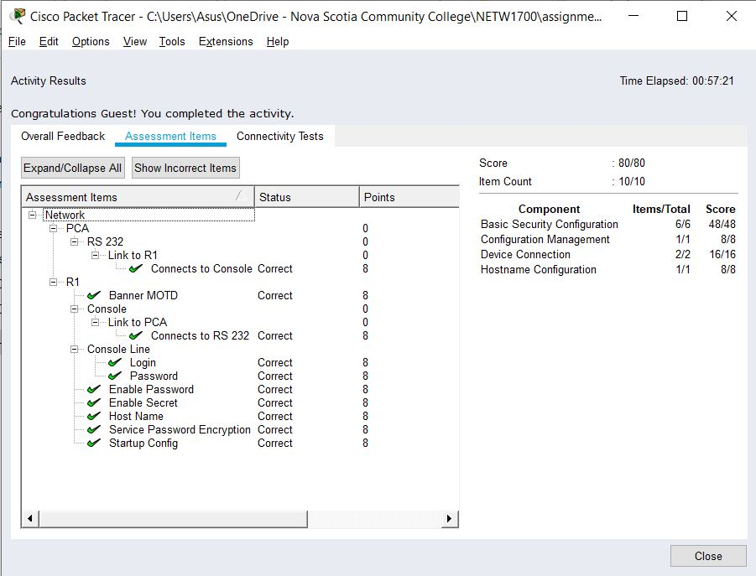

SCREENSHOT 2 OF ACTIVITY 6.4.1.3

# Question 8

## Multiple Locations 1 – Configuring Routers with a GUI

### Task 1:

Try reaching Eagle Server. The request still fails. What are some possible reasons why?

* This is because the IPv6 address has not been set

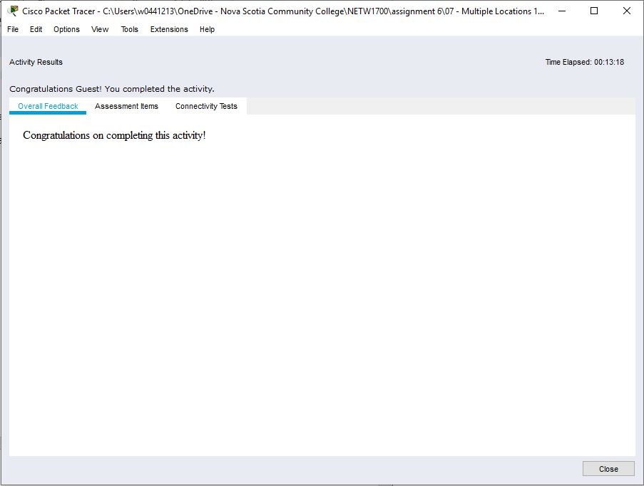

SCREENSHOT 1 OF MULTIPLE LOCATIONS 1

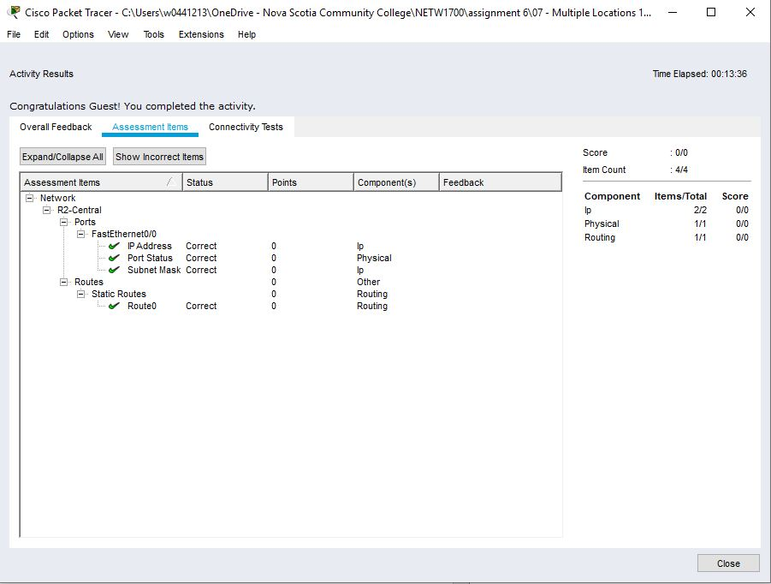

SCREENSHOT 2 OF MULTIPLE LOCATIONS 1

# Question 9

## Multiple Locations 2 – The Command Line Interface

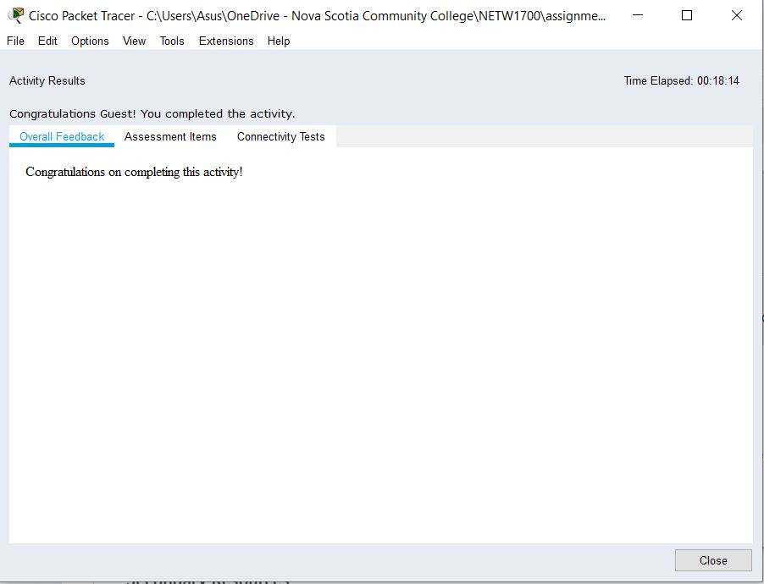

SCREENSHOT 1 OF MULTIPLE LOCATIONS 2

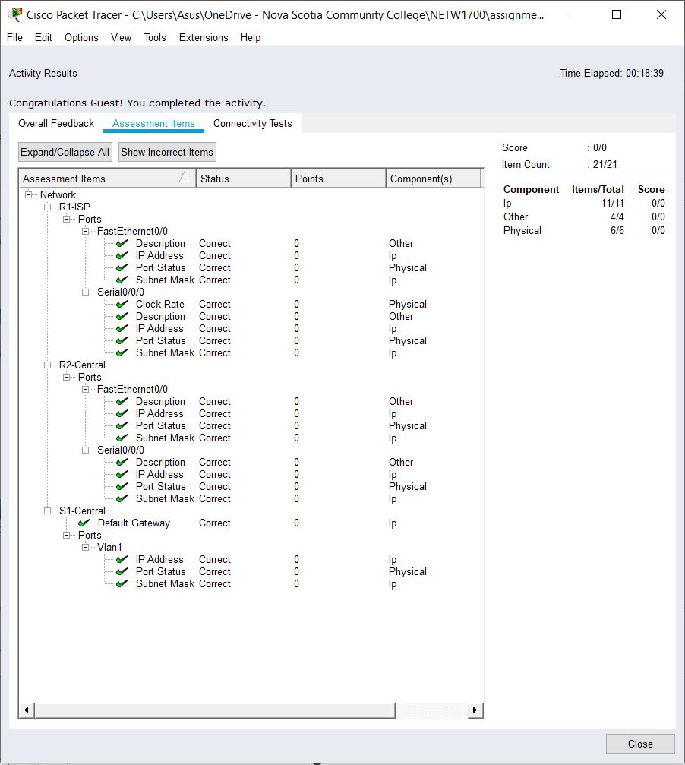

SCREENSHOT 2 OF MULTIPLE LOCATIONS 2

# Question 11

## Activity 6.5.1.3

**DEFAULT GATEWAY:**

ASw-1, User-01, and User-02 - 172.14.5.1 - G0/0

ASw-2, User-03, and User-04 - 172.14.10.1 - G0/1

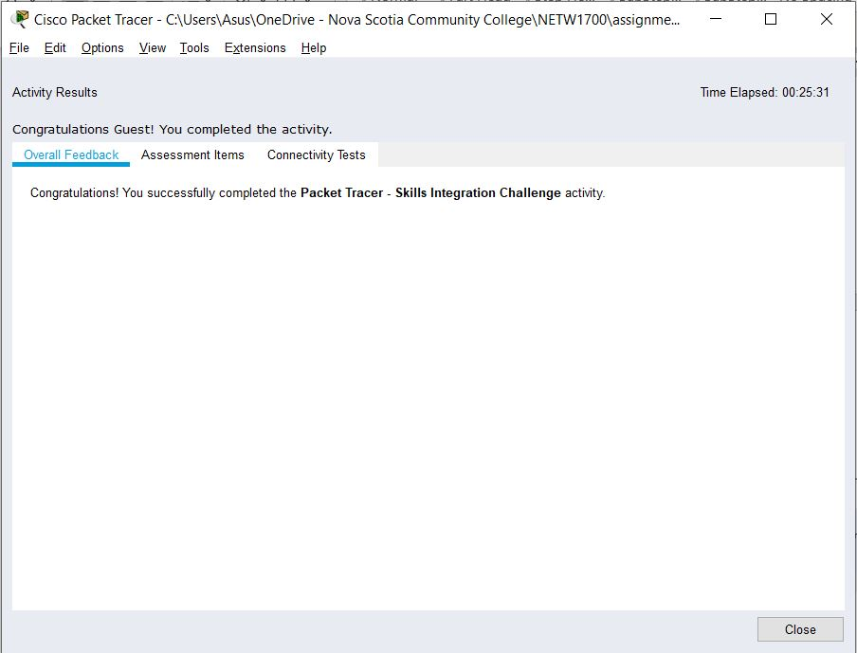

SCREENSHOT 1 OF ACTIVITY 6.5.1.3

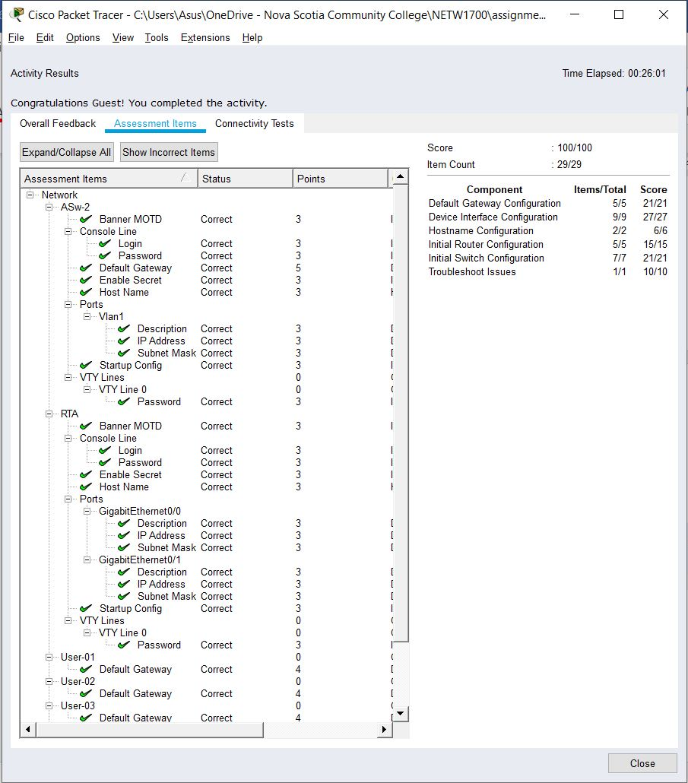

SCREENSHOT 2 OF ACTIVITY 6.5.1.3

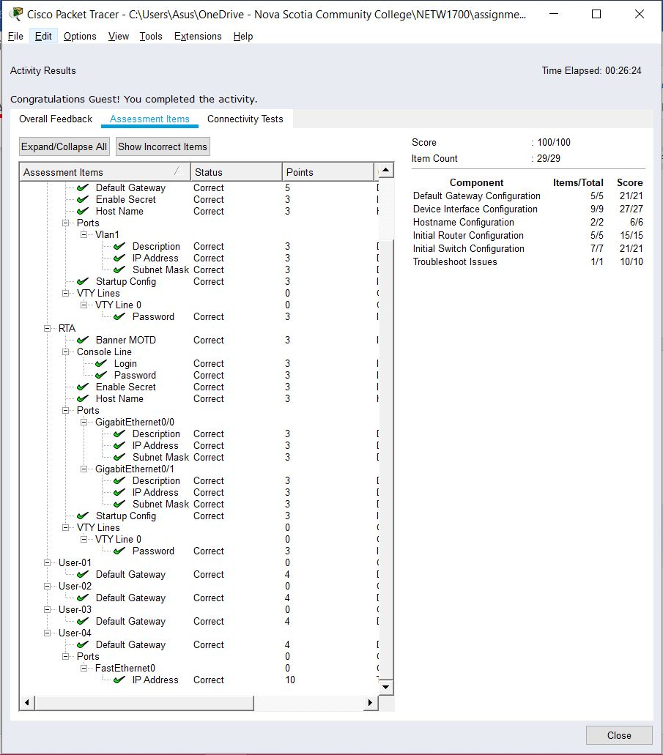

SCREENSHOT 3 OF ACTIVITY 6.5.1.3

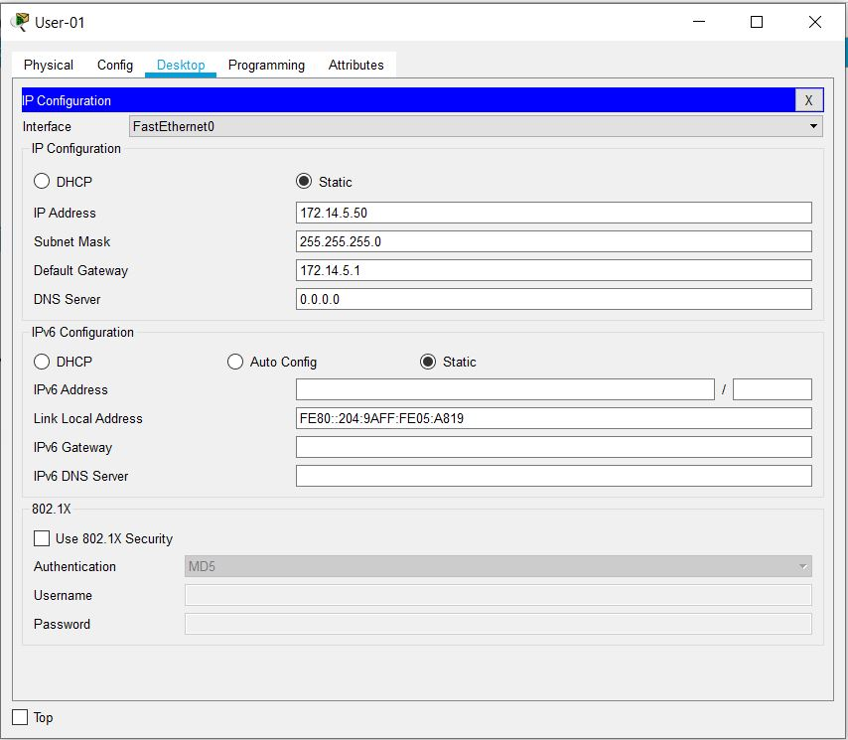

SCREENSHOT 4 OF ACTIVITY 6.5.1.3 – IP CONFIGURATION OF USER-01

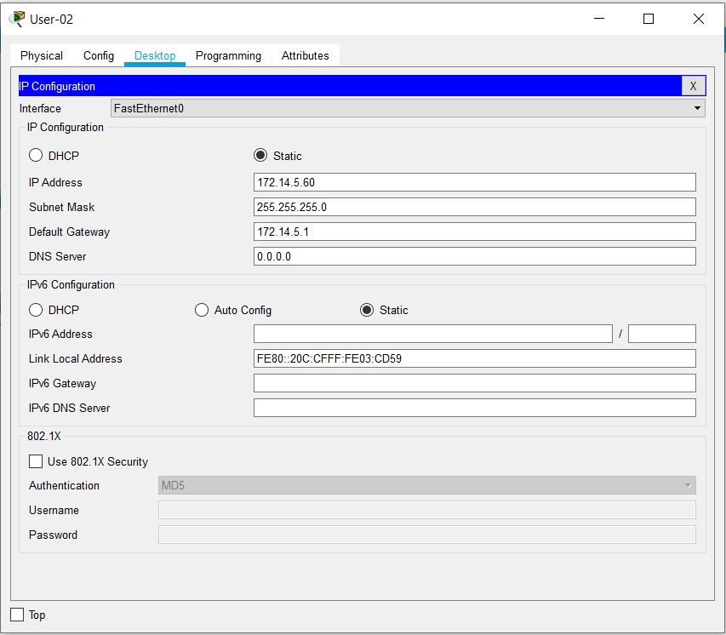

SCREENSHOT 5 OF ACTIVITY 6.5.1.3 – IP CONFIGURATION OF USER-02

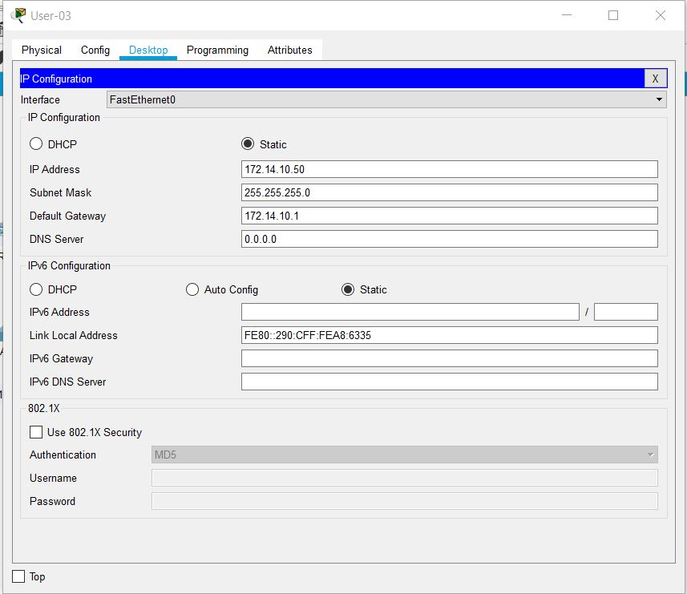

SCREENSHOT 6 OF ACTIVITY 6.5.1.3 – IP CONFIGURATION OF USER-03

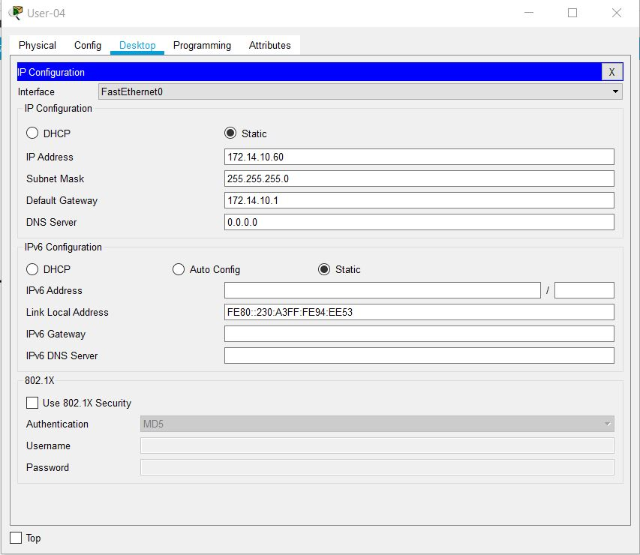

SCREENSHOT 7 OF ACTIVITY 6.5.1.3 – IP CONFIGURATION OF USER-04

# References

Cisco Networking Academy. (n.d.). *Introduction to Networks, Chapter 2: Configure a Network Operating System*. Retrieved October 10, 2019, from Cisco Networking Academy: https://static-course-assets.s3.amazonaws.com/ITN6/en/index.html#2

Cisco Systems, Inc. (2010, April). *Cisco IOS Configuration Fundamentals*. Retrieved from Cisco: https://www.cisco.com/c/en/us/td/docs/ios/fundamentals/command/reference/cf_book.pdf

# 

# Appendix

## Appendix A – Cisco Commands Tool Kit[3]

**?** – this command will show the list of all the commands available for the specific mode you are currently in.

**(characters) ?** – this command is known as context-sensitive help. it will show the available commands in the current mode with the specific first characters you have entered. (example: **te?** in the user exec mode will show **te**lnet and **te**rminal, both starting with **te**.)

**banner motd “ ”** – this command will configure the message-of-the-day banner that will display when a user logs in to the switch.

**clock rate (rate)** – this command is used in DCE in serial link. This command configures the clock speed for the ink

**clock set (time and date)** – this command will allow you to set the time and date. (example: **clock set 15:00:00 july 11 2019)**

**copy startup-config flash –** this command will save the startup configuration to the flash memory. The flash memory is good to use as a back up.

**copy running-config startup-config** – this command will save the running configuration to the startup configuration.

**config terminal** – this command will open the global configuration mode.

**description Link to (server name)** – to describe the interface of the specified server.

**enable** – this command will open the privileged exec mode and will give additional commands.

**enable password** – this command followed by a password will set that same password for the privileged exec mode.

**enable secret** – this command followed by a password will set an ***encrypted*** password for the privileged exec mode.

**exit** – this command will exit the current mode.

**Flash –** this command will boot the router from Flash memory

**ip default-gateway –** this command will set the default gateway

**hostname** – this command followed by the name you want the hostname to be will change the hostname to what you want it to be.

**interface** – followed by the interface you want to configure will open that specific interface’s configuration mode.

EXAMPLES:

**interface fa0/0** - enter interface configuration mode for the FastEthernet interface

**interface s0/0/0** – enter interface configuration mode for the serial interface

**interface vlan <1-4094>**– you can use this command to configure an svi on a switch.

**ip address ­**– this command followed by the ip address and subnet mask you want will set the ip address and subnet mask to the entered values.

**line** – this command will configure a terminal line.

**line console 0** – this command will open the line console configuration mode.

**line vty 0 15** – this command will open the virtual terminal configuration mode.

**login** – this command will enable password checking

**no shutdown** – this command enables an interface.

**password** – this command will set a password.

**ping** – this command will send a request to the destination and wait for the response. this is good for checking network connectivity.

**service password-encryption** – this command in the global config mode will encrypt all unencrypted passwords in the configuration file.

**show interface** – this command will display the status of the interfaces.

**show ip interface** – this command will display the configuration and status of the ip protocol.

**show ip interface brief** – this command gives a summary of the status and IP addresses of the interfaces

**Show flash –** this command will show the files on the flash memory.

**show running-config –** this command will show the running configuration

**show startup-config** – this command will show all the startup configuration file.

**show clock** – this command will show the time and date.

***show?*** – this command would show all the show commands in the specific mode you are currently in.

1. (Cisco Networking Academy, n.d.)
2. (Cisco Systems, Inc., 2010)
3. References and sources from (Cisco Systems, Inc., 2010)